**Chapter 1**

# INTRODUCTION

### Introduction to project

Computer Science and Engineering department webpage in a collage website plays a major role in giving information more deeply to the visitors from which colleges can grab their attention. In our project we mainly focus on Computer Science and Engineering department of a collage and try to give best to the users. So mainly we focus on 5 different categories such as Home, About us, Gallery, Teachers and Contact. In addition to this we will give brief description about computer science and engineering mission and visions.

Here we would provide even description of the categories and if they are interested in knowing more then they have an option to know more about the Computer Science and Engineering department by mailing the college for enquires or contacting them.

### Purpose

The purpose of this document is to give a detailed description of the requirements for the Computer Science and Engineering department. It will illustrate the purpose and describe the software requirement of Computer Science and Engineering.

* **Need for new devices and software-** With the advancement of technology, the world is absolutely paralyzed without the innovative devices coming up. That is the reason why there will be the need for immense manpower who are skilled in the field of computer science.
* **IT hubs require experts-**With every passing date, a number of software companies and IT hubs like Silicon Valley are increasing and therefore there is an increasing demand for skilled professionals and CSE experts.
* **Experts required for cloud computing-**With the trending concepts like cloud computing, the future technologies are depending on it and most of the companies are looking for a specialist who can actually hand give the entire segment of cloud computing and help in the progression of the business.
* **Job in telecommunications-** With the Rise in digitalization, the telecommunication systems are absolutely depending on the computer services and that is the reason why computer engineers are employed in this field.
* **Manufacturing unit of computers-** Needless to say, no one other than the computer science engineers will know how to build computers in the best possible manner. There is a reason why most of the major Fortune 500 computer manufacturing companies are looking forward to hiring more and more efficient computer science engineers.

### Objectives

The main objective of our project is to provide the visitors the detail of Computer Science and Engineering department webpage. We tried to bring the best attractive page in building this website page. We mainly concentrate on few topics and explained about the department. So mainly the visitors can get to know in brief about

* Home page
* About us page
* Gallery
* Teachers
* Contact

Here we would have given the brief description on the image but if the visitor needs to get to know more details they can click on read more option on the image we can get to know more details about the topic as we redirect the user to more details about it.

#### 1.2.1 Scope

The scope of Computer Science and Engineering department webpage in a collage website is to educate the user of the particular field. Few of such are

* **Broadly Educated and Versatile**. Able to draw upon foundational knowledge, learn, adapt and successfully bring to bear analytical and computational approaches on changing societal and technological challenges.
* **Inspiring and Collaborative**. Is a leader and a responsible citizen whose strengths come from an ability to draw on and contribute to diverse teams, expertise, and experiences.
* **Innovative.** Drives scientific and societal advancement through technological innovation and entrepreneurship.

### Overview

**Computer Science and Engineering**Students studying in this area learn about the actual machinery underlying the technologies such as the Web and Internet. In particular, they learn about:

1. Operating systems design principles, such as those found in Windows and Linux.
2. Networking technologies, such as wireless local area networks, body area networks, Internet.
3. Networking protocols, which are the languages used by communicating entities to talk to each other, e.g. HTTP, TCP/IP.
4. Networking applications, such as peer-to-peer systems, video and audio streaming systems.
5. Trustworthy computing principles, which are used to develop secure and reliable systems that can protect companies from economic loss and protect individuals from identity theft.

### Chapter 2

### REQUIREMENT ANALYSIS

#### 2.1 Existing System

The current situation is very limited to few resources, the user are unable to get knowledge more than that the webpage provides to them. Here are some of the problems of the current system:

* Details of the collage are not updated on a regular basis.
* Not very user friendly webpage.
* Not much images are made online for users to check.

#### 2.2 Proposed System

The system will hopefully serve as a centralized database of syllabus for the courses offered at the university allowing users and college, to view them. The system will end up bringing an effective communication among user, and the college, by accessing information and other resources anytime, anywhere.

Here are some expected results of the project:

* A dedicated gallery page is provided.
* More attractive and user friendly.
* More details are updated on a regular basis.

**Chapter 3**

# SOFTWARE REQUIREMENT SPECIFICATION

## 3.1 Technical Feasibility

The technical feasibility in the proposed system deals with the technology used in the system. It deals with only software and hardware used in the system whether they are of latest technology or not. It happens that after a system is prepared a new technology arises and the user wants the system based on that technology. This system use Windows platform, HTML, CSS, Bootstrap, JavaScript, as front end technology, MySQL and PHPas backend technology and PHP software that running on server. Thus About Page of VKIT is technically feasible.

## 3.2 Economical Feasibility

Economic analysis is the most frequently used method for evaluating the effectiveness of a new system. More commonly known as benefit analysis using HTML, CSS and JavaScript and MySQL easily available in internet. The economic feasibility study evaluates the cost software development against the ultimate income or benefits get from the developed system. There must be scope for profit after the success completion of the project

## 3.3 Operational Feasibility

The project has been developed in such a way that it becomes very easy even for a person with little computer knowledge to operate it. This software is very user friendly and does not require any technical person to operate. Thus the project is even operationally feasible. Operational feasibility study tests the operational scope of the software to be developed. The proposed software must have high operational feasibility. The usability will be high.

## 3.4 Hardware Requirement

The section of hardware configuration is an important task related to the software development insufficient random access memory may affect adversely on the speed and efficiency of the entire system.

The process should be powerful to handle the entire operations .The hard disk should have sufficient capacity to store the file and application.

* Processor: Pentium Dual core and above
* Process speed: 1.4 GHz Onward
* System memory: Minimum 10 Gb recommended
* Cache size: 1024 KB
* RAM: 1 Gb (Minimum)
* Hard disk: 100 Gb
* Monitor: SVGA Colour 15”
* Mouse: 104 keys US key Serial, USB or PS/2

## 3.5 Software Requirement

A major element in building a system is the section of compatible software since the software in the market is experiencing in geometric progression .Selected software should be acceptable by the firm and one user as well as it should be feasible for the system.

The document gives a detailed description of the software requirement specification .The study of requirement specification is focused specially on the functioning of the system.

It allows the developer or analyst to understand the system function to be carried out the performance level to the obtained and corresponding interfaces to be established.

* Front end tool : HTML,CSS, Bootstrap, JavaScript
* Backend : MySQL, PHP
* Operating system : Windows 2007/2008/2010

## 3.6 Tools

### HTML, CSS, JavaScript

**Hypertext Mark-up Language** (**HTML**) is the standard markup language for creating web pages and web applications. With Cascading Style Sheets (CSS) and JavaScript, it forms a triad of cornerstone technologies for the World Wide Web.

Web browsers receive HTML documents from a web server or from local storage and render the documents into multimedia web pages. HTML describes the structure of a web page semantically and originally included cues for the appearance of the document.

HTML elements are the building blocks of HTML pages. With HTML constructs, images and other objects such as interactive forms may be embedded into the rendered page. HTML provides a means to create structured documents by denoting structural semantics for text such as headings, paragraphs, lists, links, quotes and other items. HTML elements are delineated by tags, written using angle brackets. Tags such as <img/> and <**input** /> directly introduce content into the page. Other tags such as <**p**> surround and provide information about document text and may include other tags as sub-elements. Browsers do not display the HTML tags, but use them to interpret the content of the page.

Alongside HTML and CSS, JavaScript is one of the three core technologies of the World Wide Web. JavaScript enables interactive web pages and thus is an essential part of web applications. The vast majority of websites use it, and all major web browsers have a dedicated JavaScript engine to execute it.As a multiparadigm language, JavaScript supports event-driven, functional, and imperative (including object-oriented and prototype-based) programming styles. It has an API for working with text, arrays, dates, regular expressions, and basic manipulation of the DOM, but the language itself does not include any I/O, such as networking, storage, or graphics facilities, relying for these upon the host environment in which it is embedded. JavaScript typically relies on a run-time environment (e.g., a Web browser) to provide objects and methods by which scripts can interact with the environment (e.g., a webpage DOM). It also relies on the run-time environment to provide the ability to include/import scripts .

### MySQL

**MySQL** is an open source relational database management system (RDBMS). Its name is a combination of "My", the name of co-founder Michael Widenius's daughter, and "SQL", the abbreviation for Structured Query Language. The MySQL development project has made its source code available under the terms of the GNU General Public License, as well as under a variety of proprietary agreements. MySQL was owned and sponsored by a single forprofit firm, the Swedish company MySQL AB, now owned by Oracle Corporation.[[8]](https://en.wikipedia.org/wiki/MySQL#cite_note-sunacquire-8) For proprietary use, several paid editions are available, and offer additional functionality. MySQL is a central component of the LAMP open-source web application software stack (and other "AMP" stacks). LAMP is an acronym for "Linux, Apache, MySQL, and Perl/PHP/Python”.

Applications that use the MySQL database include:

* TYPO3
* MODx
* Joomla
* WordPress
* Simple Machines Forum
* phpBB
* MyBB and
* Drupal.

MySQL is also used in many high-profile, large-scale websites, including Google, Facebook, Twitter, Flickr, and YouTube. Major features as available in MySQL 5.6:

* A broad subset of ANSI SQL 99, as well as extensions
* Cross-platform support
* Stored procedures, using a procedural language that closely adheres to SQL/PSM
* Triggers

**Chapter 4**

# ANALYSIS AND DESIGN

## 4.1 Analysing the problem

There will be a Computer Science Department home page where all the information regarding the branch is visible:

### 4.1.1 Home

The system home page will have full information regarding the details of the department and also the program expected outcome.

### 4.1.2 Testimonial

The students who have worked on development of the project is given at the testimonial part of the home page.

**4.1.3 Operations**

The user is able to do the following:-

* View about us page
* Gallery
* Teachers information
* Way to contact the college

### About us Page content:-

* Head of the Department Information
* Mission and Vision

**Gallery Page:-**

* Overview images of the department view

## 4.2 Design of project

The design specifies the design of various aspects and different aspects of the project. Design is the ultimate framework of the project. In the sense, the design is a plan or a mindful blueprint of the project to be developed. The following diagrams shows the flow of the output window.

### User case Diagram



### 

### Fig.4.1 Use case diagram

The above use case diagram helps to know how the users can access and have an control over the system.

## Chapter 5

## IMPLEMENTATION

Implementation is the stage where all planned activities are put into action. Before the implementation of a project, the implementers (spearheaded by the project committee or executive) should identify their strength and weaknesses (internal forces), opportunities and threats (external forces).

### 5.1 Code Segment

**5.1.1 Loader**

    <!-- LOADER -->

    <div id="preloader">

        <div class="loader-container">

            <div class="progress-br float shadow">

                <div class="progress__item"></div>

            </div>

        </div>

    </div>

    <!-- END LOADER -->

**5.1.2 Header**

    <!-- Start header -->

    <header class="top-navbar">

        <nav class="navbar navbar-expand-lg navbar-light bg-light">

            <div class="container-fluid">

                <a class="navbar-brand" href="index.html">

                    <img src="images/vkitlogo.png" alt="" />

                    <span class="head"><strong style="color: rgb(236, 231, 238);">Vivekananda Institute Of Technology</strong></span>

                </a>

                <button class="navbar-toggler" type="button" data-toggle="collapse" data-target="#navbars-host" aria-controls="navbars-rs-food" aria-expanded="false" aria-label="Toggle navigation">

                    <span class="icon-bar"></span>

                    <span class="icon-bar"></span>

                    <span class="icon-bar"></span>

                </button>

                <div class="collapse navbar-collapse" id="navbars-host">

                    <ul class="navbar-nav ml-auto">

                        <li class="nav-item active"><a class="nav-link" href="#">Home</a></li>

                        <li class="nav-item"><a class="nav-link" href="about.html">About Us</a></li>

                        <li class="nav-item"><a class="nav-link" href="gallery.html">Gallery</a></li>

                        <li class="nav-item"><a class="nav-link" href="teachers.html">Teachers</a></li>

                        <li class="nav-item"><a class="nav-link" href="contact.html">Contact</a></li>

                    </ul>

                </div>

            </div>

        </nav>

     </header>

     <!-- End header -->

**5.1.3 Footer**

    <footer class="footer">

        <div class="container">

            <div class="row">

                <div class="col-lg-4 col-md-4 col-xs-12">

                    <div class="widget clearfix">

                        <div class="widget-title">

                            <h3>About US</h3>

                        </div>

                        <p>At VKIT the department of Computer Science and Engineering started functioning since 1997.

                            The qualified experienced 17 faculty, along 03 staff adds the value to the undergraduate and

                             post graduate students.

                        </p>

                        <div class="footer-right">

                            <ul class="footer-links-soi">

                                <li><a href="#"><i class="fa fa-facebook"></i></a></li>

                                <li><a href="#"><i class="fa fa-github"></i></a></li>

                                <li><a href="#"><i class="fa fa-twitter"></i></a></li>

                                <li><a href="#"><i class="fa fa-dribbble"></i></a></li>

                                <li><a href="#"><i class="fa fa-pinterest"></i></a></li>

                            </ul><!-- end links -->

                        </div>

                    </div><!-- end clearfix -->

                </div><!-- end col -->

                <div class="col-lg-4 col-md-4 col-xs-12">

                    <div class="widget clearfix">

                        <div class="widget-title">

                            <h3>Information Link</h3>

                        </div>

                        <ul class="footer-links">

                            <li><a href="#">Home</a></li>

                            <li><a href="about.html">About</a></li>

                            <li><a href="gallery.html">Gallery</a></li>

                            <li><a href="teachers.html">Teachers</a></li>

                            <li><a href="contact.html">Contact</a></li>

                        </ul><!-- end links -->

                    </div><!-- end clearfix -->

                </div><!-- end col -->

                <div class="col-lg-4 col-md-4 col-xs-12">

                    <div class="widget clearfix">

                        <div class="widget-title">

                            <h3>Contact Details</h3>

                        </div>

                        <ul class="footer-links">

                            <li><a href="#">vkit@blr.com</a></li>

                            <li><a href="#">www.vkitbangalore.com</a></li>

                            <li>Kumbalagodu, Kengeri, Bengaluru-560074</li>

                            <li>T: +91 94803 39078</li>

                        </ul><!-- end links -->

                    </div><!-- end clearfix -->

                </div><!-- end col -->

            </div><!-- end row -->

        </div><!-- end container -->

    </footer><!-- end footer -->

**Chapter 6**

## TESTING

The purpose of testing is to discover errors. Testing is the process of trying to discover every conceivable fault or weakness in a work product. It provides a way to check the functionality of components, sub-assemblies, assemblies and/or a finished product. It is a process of exercising software with the intent of ensuring that the Software system meets its requirements and user expectations and does not fail in an unacceptable manner. There are various types of test. Each test type addresses a specific testing requirement.

**Types of Testing Techniques**

### 6.1 White box testing

White Box Testing is a testing in which the software tester has knowledge of the inner workings, structure and language of the software, or at least its purpose. It is used to test areas that cannot be reached from a black box level.

### 6.2 Black box testing

Black Box Testing is testing software without any knowledge of the inner workings, structure or language of the module being tested. It is a testing in which the software under test is treated, as a black box you cannot “see” into it. The test provides inputs and responds to outputs without considering how the software works.

### 6.3 Grey box testing

This involves having knowledge of internal data structures and algorithms for purpose of designing tests, while executing those tests at the user, or black-box level. Manipulating input data and formatting output do not qualify as grey box, because the input and output are clearly outside of the “black box” that we are calling the system under test.

### 6.4 Test cases

#### 6.4.1 Test case for user interface

|  |  |  |
| --- | --- | --- |
| **Steps** | **Test Action** | **Results** |
| Step 1 | Run the program | Successful display of the Welcoming index page. |
| Step 2 | Press a gif button | Redirects to a page which includes student login. |
| Step 3 | Press on admin image | Redirects to a page where admin manages various tasks. |
| Step 4 | Displaying on the Grid view | The entries made are displayed on grid view for a detailed understanding of the user. |
| Step 5 | Reflection in the database | The change made in the front end by the user is reflected in the database as well. |

**Table 6.1 Test case for user interface**

1. Student input: The required details of the student are entered during their registration.
2. Error handling: In this system we have tried to handle all the errors that occurred while running the application. The common errors we saw were reading a row with an attribute set to null and the database connection getting lost.

#### 6.4.2 Integration Testing

Data can be lost across an interface, one module can have an adverse effect on the other sub function, when combined may not produce the desired functions. Integrated testing is the systematic testing to uncoverthe errors with an interface. This testing is done with simple data and developed system has run successfully with this simple data. The need for integrated system is to find the overall system performance.

Steps to perform integration testing:

Step 1: Create a test plan

Step 2: Create Test Cases and Test Data

Step 3: Once the components have been integrated execute the test cases

Step 4: Fix the bugs if any and re test the code

Step 5: Repeat the test cycle until the components have been successfully integrated

|  |  |
| --- | --- |
| **Name of the Test** | **Integration testing** |
| Test plan | To check whether system works properly when all the modules are integrated. |
| Test data | The data entered by the admin. |

**Table 6.2 Test case for integration testing**

#### 6.4.3 System Testing

Ultimately, software is included with other system components and the set of system validation and integration tests are performed. System testing is a series of different tests whose main aim is to fully exercise the computer-based system.

|  |  |
| --- | --- |
| **Name of the Test** | **System Testing** |
| Item being tested | The working of the pages for each request made by the user. |
| Sample Input | Student details for registration and admin’s reference purpose. |
| Expected Output | Redirection to the appropriate page upon registration which requires the user to login and proceed to vote. |
| Actual Output | Shows the number of votes made by the students in a separate grid. |
| Remarks | Successful |

**Table 6.3 Test case for input-output**

6.4.4 Validation Testing

At the culmination of black box testing, software is completely assembled is as a package. Interfacing errors have been uncovered and the correct and final series of tests, i.e., validation tests begins. Validation test is defined with a simple definition that validation succeeds when the software function in a manner that can be reasonably accepted by the customer.

#### 6.4.5 Output Testing

After performing validation testing, the next step is output testing of the proposed system. Since the system cannot be useful if it does not produce the required output. Asking the user about the format in which the system is required tests the output displayed or generated by the system is required tests the output displayed or generated by the system under consideration. The output format is considered in two ways, one is on screen format and the other is printed format. The output testing does not result in any correction in the system.

#### 6.4.6 Test data and Output

Taking various kind soft data plays a vital role in system testing. After preparing the test data system under study is tested using the test data. While testing, errors are again uncovered and corrected by using the above steps and corrections are also noted for future use.

#### 6.4.7 User acceptance Testing

User acceptance testing of the system is the key factor for the success of the system. A system under consideration is tested for user acceptance by constantly keeping in touch with the prospective system at the time of development and making change whenever required. This is done with regard to the input screen design and output screen design.

#### 6.4.8 GUI Testing

GUI testing is use to ensure the visual clarity of the system, flexibility of the system and user friendliness of the system. The various components which are to be tested are:

1. Relative layout
2. Various Links and Buttons

## Chapter 7

### SNAPSHOTS

The experimental results are shown by giving some snapshots of the output of this project. The following are some of them.

### 7.1 Home Page

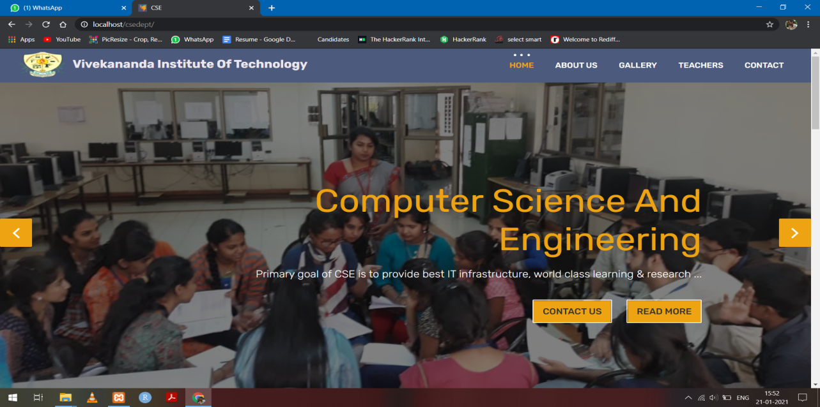

**Fig. 7.1.1**

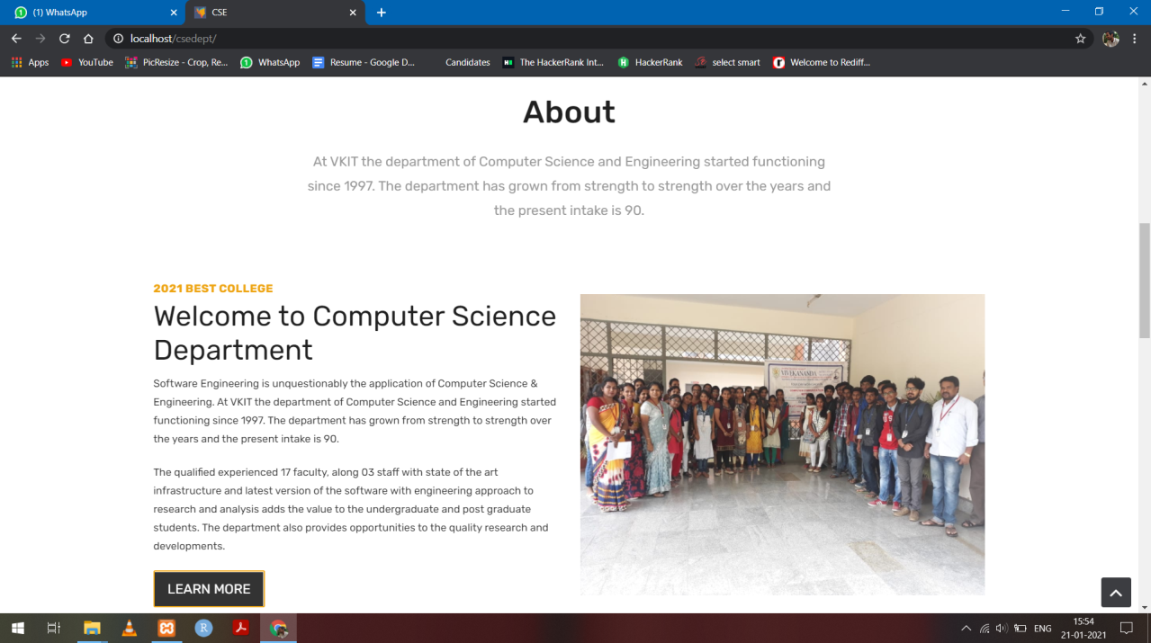

**Fig. 7.1.2**

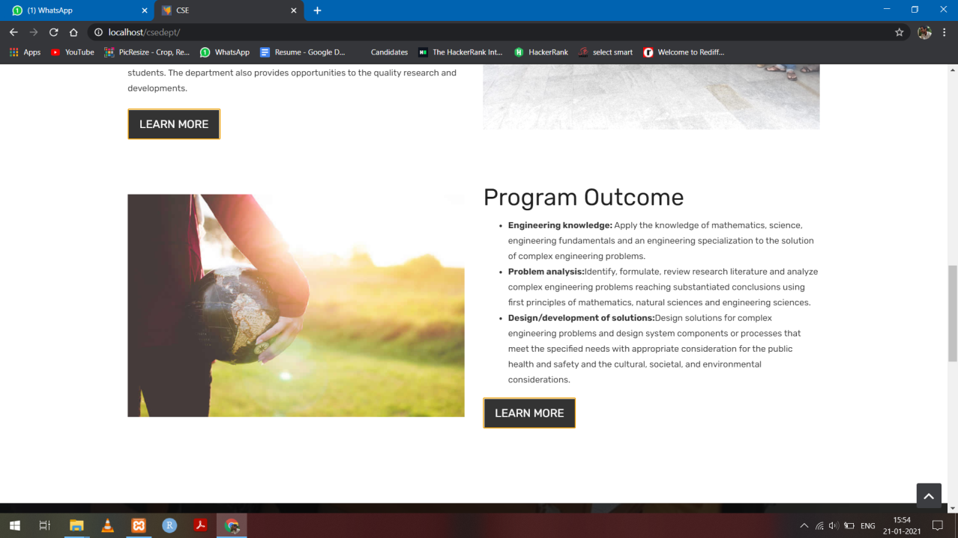

**Fig. 7.1.3**



**Fig. 7.1.4 Home page of Computer Science Department.**

This snapshot is a immediate display when the site is opened.

### 7.2 About Page

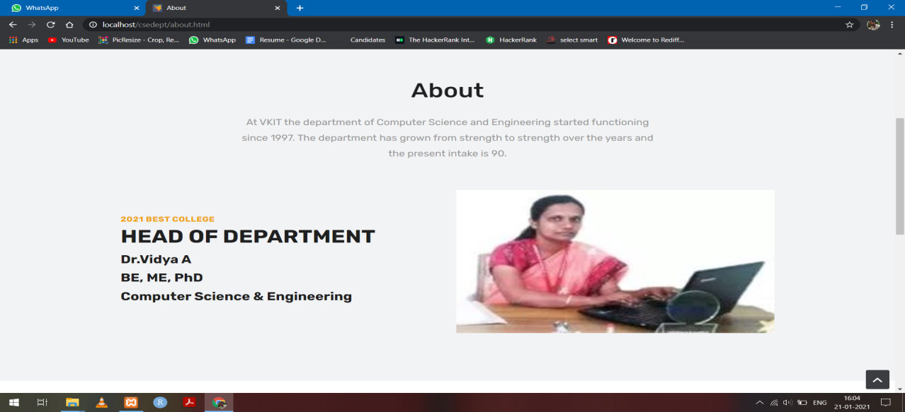

**Fig. 7.2.1**

#### Screenshot (74).png

#### Fig.7.2.2 About Page of CSE Department

This page gives the about information of the CSE department.

### 7.3 Gallery Page

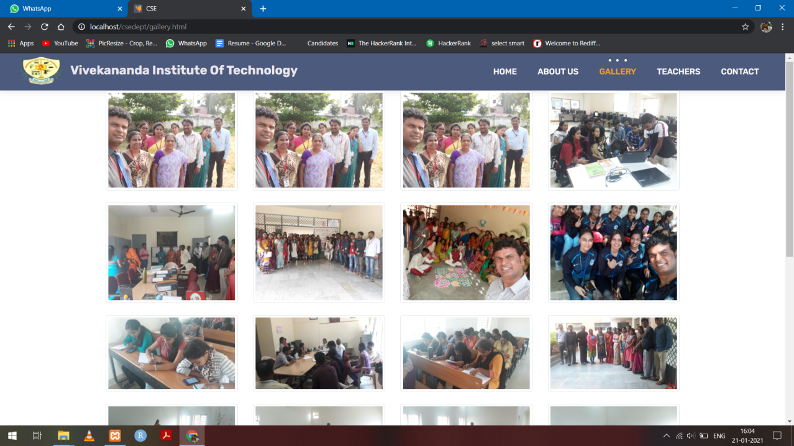

**Fig. 7.3. Gallery Page of CSE Department**

This page consists of events images of life in CSE Department.

**7.4 Teachers Page**

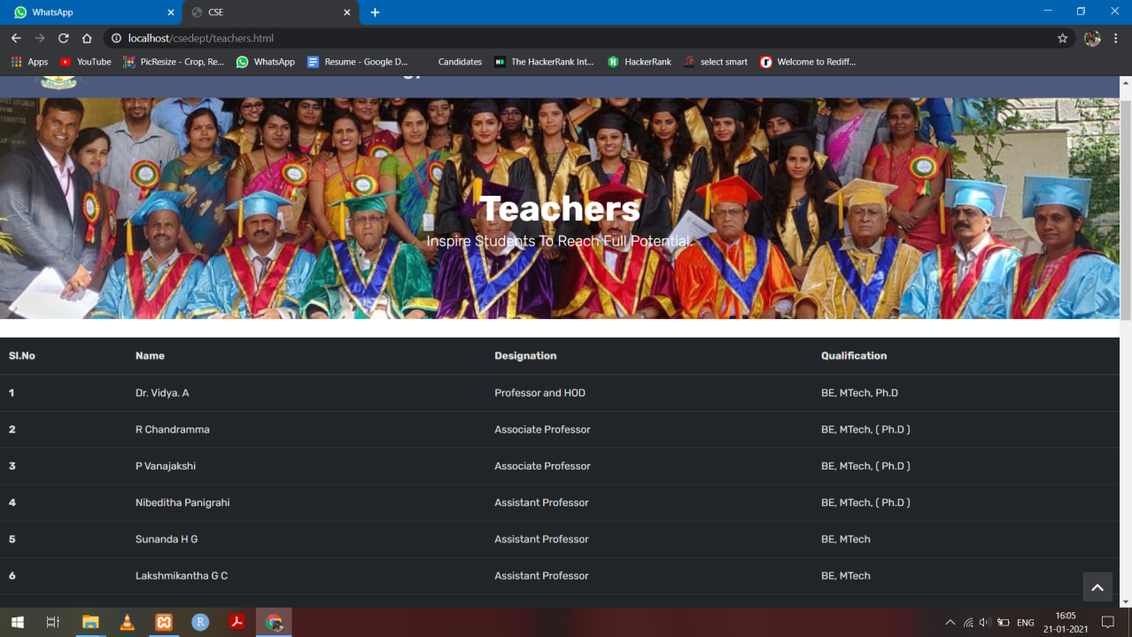

**Fig. 7.4 Teachers Information**

### 7.5 Contact us Page

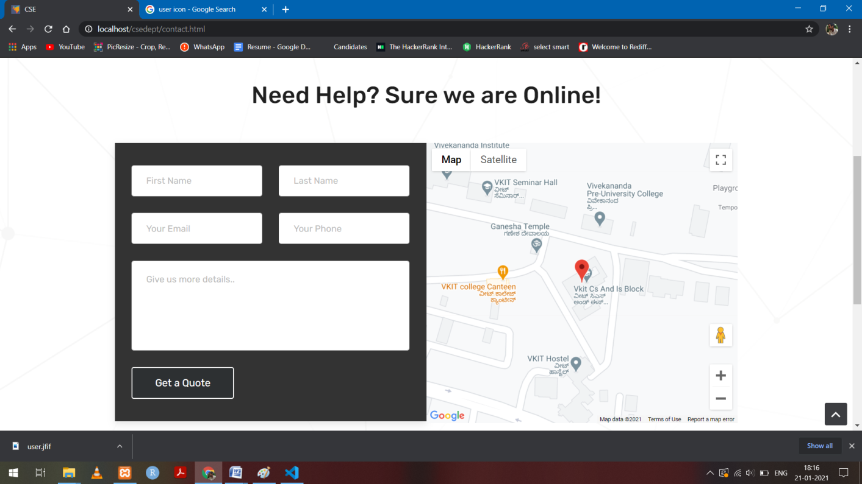

**Fig. 7.5 The contact us Page**

Here we can ask the college about any query and locate the college on Google maps.

# CONCLUSION & FUTURE REFERENCE

In our webpage of Computer Science and engineering department we will get all the required information about the department and it’s environment. We can also view the information about all the teachers qualifications and we can mail or contact the college enquiring for more required details. We also offer a wide base of photos of the college and what it has to offer the visitors and our webpage is flexible and user friendly to access

The webpage will bring about frequent updating of details and things so it's more friendly and accurate to the visitors.

We can implement the same project using MEAN Stack which will provide better efficiency and fast and interactive interface,

# BIBLIOGRAPHY

**Books Referred:**

1. Randy Conolly, Ricardo Hoar, “Fundamentals of Web Development”, 1st Edition Pearson Education India.
2. Robin Nixon, “Learning PHP, MySQL & JavaScript with Jquery, CSS and HTML5”, 4th Edition, O’Reilly Publications, 2015.
3. Luke Welling, Laura Thomson, “PHP and MySQL Web Development”, 5th Edition,Pearson Education, 2016.
4. David Sawyer McFarland, “JavaScript & JQuery”, 1st Edition, O’Reilly/Shroff Publishers & Distributors Pvt Ltd, 2014.

**Web Sites Referred:**

1. https://en.wikipedia.org/wiki/Blog
2. https://edublogs.org
3. https://www.google.com/
4. https://www.w3schools.com/php/php_mysql_create.asp